**CENG 103 LAB 2 25.10.2016**

**1)** Calculating BMI (Body Mass Index):

BMI = weight / square of height

In this question, you will calculate BMI for the values which are taking from the user. According to the BMI;

(0-20) 🡪 Weak

(20-30) 🡪 Normal

(30-40) 🡪 Fat

( >40) 🡪 Risky

**2) $f \left(x,y\right)=x^{2}y+ \sqrt{2xy}+y+1$**

In this question, you will calculate the function f, for two **integer** variables which are taking from user and output will be;

f ( … , … ) = … ;

**3)** We will be writing a simple program that will swap the values of two variables, num1 and num2.

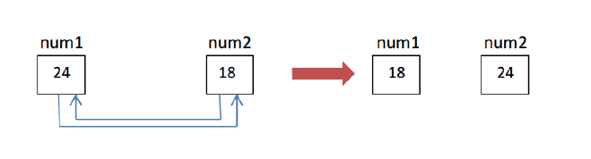

Once the value of two variables are entered by the user from the keyboard, display them on the screen with the address of each variable. Then swap the values and display the same information as shown below.

num1 --- value=24, address = 2293572 **address value can be different**

num2 --- value=18, address = 2293568 **in your machine**

After the swap

num1 --- value=18, address = 2293572 **but after swap they need to**

num2 --- value=24, address = 2293568 **stay same.**

**4) a)** Write a program that takes an **integer** number and decides if it is “Even” or “Odd”. Then print the result.

**b)** Decide that number Even or odd, and multiple of 10. The output should be:

-> The number is ODD

-> The number is not multiple of 10 but EVEN.

-> The number is multiple of 10 and EVEN.

**5)** You will write a program that calculates the volume of a sphere with an **integer** radius. You will take the radius from the user and prints the result as follows;

**Important:** You will use PI as 3.14 and you will use **#define** to create the constant

-> The volume of a sphere with radius … is …

For the blanks you will put values.

**Hint:** Volume of sphere = ${4/3πr}^{3}$